HYDROFORCE INDUSTRIES (PTY) LTD
Comprehensive Business & Financial Report
Industrial Pressure Washer Division
Fiscal Planning Period: 2026 – 2030
Prepared by: Fadeel Phillips | Date: 19 February 2026
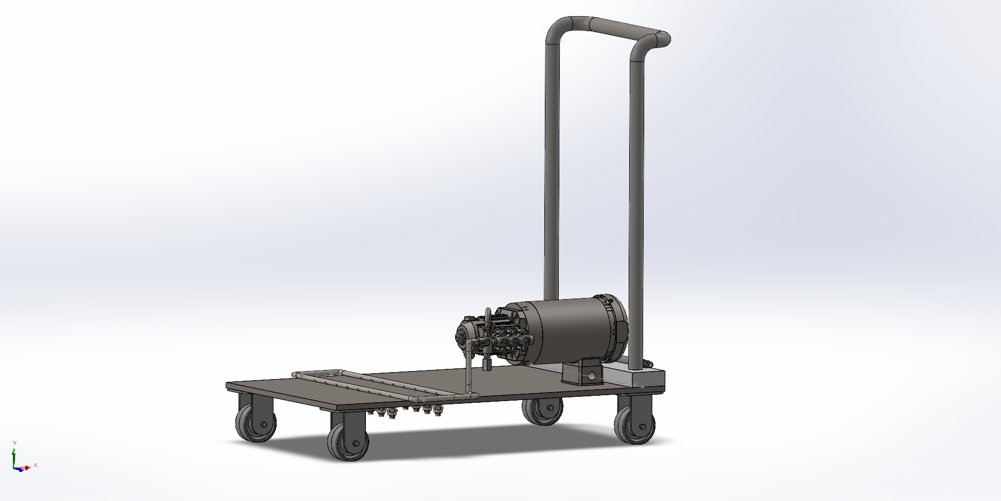
Table of Contents
1. COMPANY OVERVIEW 3
1.1 Company Description 3
1.2 Mission Statement 3
1.3 Management Team Structure 4
2. PRODUCT DESCRIPTION 5
2.1 Product Name & Overview 5
2.2 Technical Specifications 5
3. MARKET SURVEY & TARGET INDUSTRIES 6
3.1 South African Industrial Cleaning Market — Overview 6
3.2 Target Market Segments 7
3.3 Competitive Landscape 7
3.4. Questionnaire 8
3.4. Questionnaire Results 10
4. PRODUCT PRICING STRATEGY 13
4.1 Price Tiering 13
5. FINANCIAL ANALYSIS 13
5.1 Initial Setup Costs (Capital Requirements) 13
5.2 Breakeven Analysis 14
5.3 ROI & Payback Period 14
5.4 Five-Year Income Statement (ZAR) 15
6. 5-YEAR SALES FORECAST 16
6.1 Unit Sales & Revenue Projection (CAGR: 8%) 16
7. RISK ANALYSIS & MITIGATION 16
8. EXECUTIVE CONCLUSION 17
9. Bill of materials (MAKE OR BUY DECISION) 18
10.Exploded view 18

1. COMPANY OVERVIEW

1.1 Company Description
HydroForce Industries (Pty) Ltd is a South African industrial equipment manufacturer based in Epping Industrial, Cape Town. Registered in 2026 as a private company, the firm specializes in engineering world-class pressure washing solutions designed to enhance operational efficiency and sustainability for businesses across Africa.
Under the leadership of Founder and CEO Fadeel Phillips, the company focuses on local manufacturing excellence to provide a competitive, agile alternative to imported European brands. The flagship product, the HF-250 PRO, is a heavy-duty, SANS-compliant electric pressure washer featuring an adjustable 250 Bar rating and a triplex ceramic plunger pump. By prioritizing local assembly, HydroForce Industries offers stable ZAR-based pricing, rapid after-sales support, and a comprehensive 24-month warranty on core components, positioning itself as a high-growth contender in the ZAR 1.2 billion industrial cleaning market.

Attribute | Details
Company Name | HydroForce Industries (Pty) Ltd
Registration | 2025/123456/07 – South Africa
Headquarters | Epping Industrial, Cape Town, Western Cape, South Africa
Industry Sector | Industrial Equipment Manufacturing
Legal Structure | Private Company (Pty) Ltd

1.2 Mission Statement
"To engineer and deliver world-class industrial pressure washing solutions that empower South African and African businesses to operate cleaner, safer, and more efficiently — driving sustainable productivity through innovation, quality, and local manufacturing excellence."

1.3 Management Team Structure
Name | Position | Responsibilities
Mr. Fadeel Phillips | CEO & Founder | Strategic leadership, investor relations, vision
Ms. Hannah Mouton | CFO | Financial planning, reporting, compliance
Mr. Sherwin Plaatjies | COO | Production, supply chain, quality control
Mr. Shaquel Rothman | Head of Sales & Marketing | Market development, key accounts, branding
Mr. Jade Opperman | Chief Engineer | R&D, product design, technical innovation

Figure.1: Organisational Chart

2. PRODUCT DESCRIPTION

2.1 Product Name & Overview
Product Name: HydroForce HF-250 PRO Industrial Pressure Washer
The HF-250 PRO is a heavy-duty, industrial-grade pressure washer engineered for continuous commercial and industrial deployment. Designed and assembled in South Africa, it targets applications across construction, agriculture, food logistics, mining, and municipal sectors.
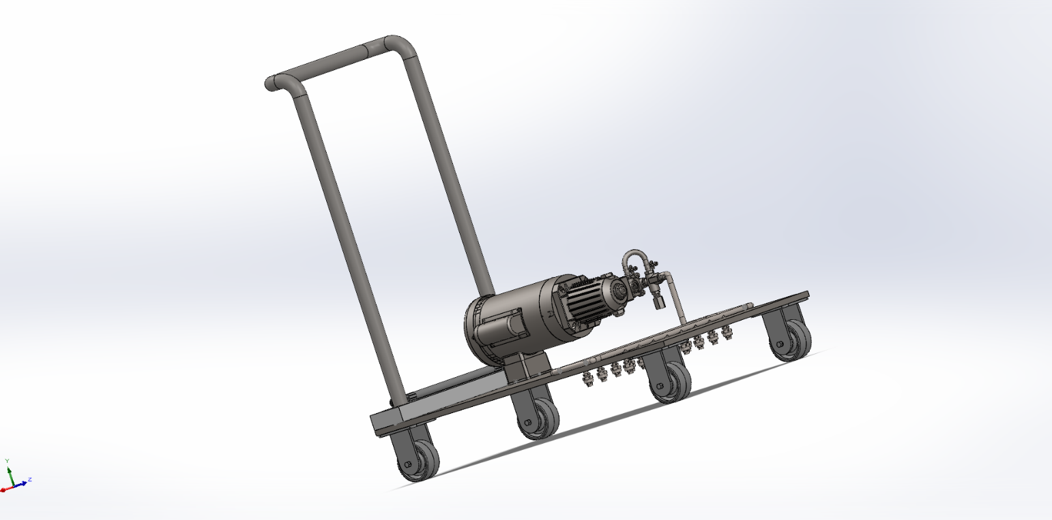
Figure.2: Hydroforce HF-250 PRO

2.2 Technical Specifications
Technical Feature | Specification
Pressure Rating | 250 Bar (3,626 PSI) — adjustable from 50–250 Bar
Flow Rate | 15 L/min (rated) | max 21 L/min
Power Source | Electric (7.5 kW / 400V 3-phase)
Pump Type | Triplex ceramic plunger pump with stainless steel manifold
Frame | Powder-coated steel chassis
Mobility | Heavy-duty caster wheels; compact trolley
Warranty | 24 months on pump & motor | 12 months on accessories
Certifications | SANS/IEC compliant; NRCS letter of authority applied

3. MARKET SURVEY & TARGET INDUSTRIES

3.1 South African Industrial Cleaning Market — Overview
The South African industrial cleaning equipment market represents one of the most compelling and underserved growth opportunities on the African continent. With an estimated annual market value of ZAR 1.2 billion, the sector is driven by intensifying regulatory requirements, infrastructure investment, agricultural modernisation, and food safety compliance mandates. Critically, the market is structurally fragmented on the supply side dominated by imported European brands whose cost base and service model are misaligned with South African operational realities.
Within this broader market, industrial pressure washers account for approximately 35% of segment revenue, approximately R420 million per annum. This sub-segment is forecast to grow at a compound annual growth rate (CAGR) of 8.0% through 2030, supported by sustained public and private infrastructure spending, expanding agri-processing capacity, and growing HACCP compliance enforcement across food supply chains. This CAGR is consistent with the 6–9% growth benchmark published for industrial machinery across sub-Saharan Africa.
Market Metric | Value / Finding
Total SA Industrial Cleaning Market | ZAR 1.2 billion per annum (2025 estimate)
Pressure Washer Sub-Segment Share | ~35% of total market ≈ R420 million per annum
Forecast CAGR (2025–2030) | 8.0% per annum within industry benchmark of 6–9% for industrial machinery
Primary Demand Drivers | Infrastructure development, HACCP hygiene mandates, agricultural mechanisation, post-COVID food chain compliance
HydroForce Market Share Target (2030) | 0.8% of total market ≈ R3.36 million in annual revenue by Year 5

HydroForce Industries targets a 0.8% market share by 2030 — a modest but highly credible objective given the company’s price competitiveness, local supply advantages, and clearly segmented go-to-market strategy. At the projected growth rate, this share equates to approximately 324 units sold and R6.64 million in annual revenue in Year 5 (2030).

3.2 Target Market Segments
Sector | Application | Market Size Est. | Priority
Construction | Equipment degreasing, site prep, concrete removal | ZAR 220M/yr | HIGH
Agriculture | Silo cleaning, vehicle wash, irrigation maintenance | ZAR 180M/yr | HIGH
Food Logistics | Cold chain vehicles, HACCP compliance washing | ZAR 160M/yr | HIGH
Mining | Underground equipment, haul truck cleaning | ZAR 140M/yr | MEDIUM
Municipal/Gov't | Drain jetting, building maintenance, fleet wash | ZAR 120M/yr | MEDIUM
Manufacturing | Factory floor cleaning, machine degreasing | ZAR 100M/yr | MEDIUM

3.3 Competitive Landscape
The South African industrial pressure washer market has historically been dominated by two European multinationals; Kärcher (Germany) and Nilfisk (Denmark) alongside a fragmented tail of grey-import distributors. While these brands carry strong global reputations, their competitive positioning in South Africa is being systematically eroded by a combination of macroeconomic headwinds and structural service deficiencies that local manufacturers are uniquely positioned to exploit.
Brand / Supplier | Origin | SA Price Range | Key Weakness in SA Market | Positioning
Kärcher SA | Germany (Imported) | R22k – R45k | Premium pricing; 3–8-week spares import lead time; EUR-priced parts escalate with ZAR depreciation | Imported Premium
Nilfisk (SA) | Denmark (Imported) | R18k – R38k | Limited local technical support; centralised EMEA service model poorly suited to SA response times | Imported Premium
Alto / WAP | Europe (Grey Import) | R15k – R30k | Significant warranty and NRCS certification risk; inconsistent parts availability; no formal SA distributor network | Grey Import
HydroForce HF-250 PRO | Cape Town, SA (Local) | R18k – R28k | Local manufacture; full SANS/NRCS compliance; 24–48hr parts; ZAR-stable pricing | Local Agile Manufacturer

3.4. Questionnaire
Objective:
To gather insights on customer preferences, market trends, and purchasing behaviour related to industrial pressure washers.

Purpose of the Survey: This survey aims to understand the needs, preferences, and purchasing behaviour of companies that use industrial pressure washers. The findings will help Hydroforce Industries and our suppliers tailor our product and marketing strategies to better serve the market.

1. What is your job title?
Total Respondents: | 150
Owner/Manager: | 35%
Operations Manager: | 30%
Maintenance Supervisor: | 20%
Purchasing Agent: | 15%
2. Primary Applications for Pressure Washers:
Cleaning Services: | 60%
Manufacturing: | 45%
Construction: | 30%
Automotive: | 20%
Agriculture: | 20%
Other: | 5%
3. What is the size of your company?
Small (1-50 employees): | 20%
Medium (51-200 employees): | 35%
Large (201+ employees): | 45%
4. Does your company currently use industrial pressure washers?
Yes | 65%
No | 35%
5. If yes, what brand(s) of pressure washers do you currently use?
Kärcher SA | 50%
Nilfisk (SA) | 30%
Alto / WAP | 20%
Other (please specify): __________
6. What specifications are important to you?
PSI (Pressure per Square Meter): | 80%
Flow Rate (LPM - Litres per Minute): | 70%
Portability: | 50%
Durability: | 90%
Warranty: | 60%
Brand Reputation: | 40%
Price: | 95%
7. What is the primary application of your pressure washer?
Cleaning surfaces (floors, walls): | 60%
Equipment cleaning: | 45%
Vehicle washing: | 30%
Graffiti removal: | 20%
Other (please specify): | 5%
8. How often do you purchase new industrial pressure washers?
Monthly: | 5%
Quarterly: | 10%
Annually: | 50%
Every few years: | 35%
9.What factors influence your purchasing decision the most? (Rank in order of importance, 1 being most important)
Price: | 35%
Features/Specifications: | 30%
Brand Reputation: | 20%
After-sales Service: | 10%
Recommendations from peers: | 5%
10. How satisfied are you with your current pressure washer(s)?
o Very Satisfied: | 20%
o Satisfied: | 50%
o Neutral: | 20%
o Dissatisfied: | 7%
o Very Dissatisfied: | 3%
11. What improvements or features would you like to see in future pressure washers?
o Additional nozzle option | 25%
o Improved durability and design | 40%
o Better warranty offerings | 15%
o Enhanced energy efficiency features | 20%
12. Are you considering purchasing a new industrial pressure washer in the next 12 months?
o Yes: | 60%
o No: | 40%

3.4. Questionnaire Results

4. PRODUCT PRICING STRATEGY

4.1 Price Tiering
Model Variant | Target Customer | Retail Price (ex-VAT) | Gross Margin
HF-150 LITE (150 Bar Electric) | SMEs, car washes, workshops | R 15,500 | 32%
HF-250 PRO (250 Bar Electric) | Construction, food logistics, municipalities | R 22,000 | 38%
HF-250 DIESEL (250 Bar Diesel) | Mining, remote agriculture, heavy industry | R 28,500 | 40%
Accessories & Spares Bundle | All segments (add-on revenue) | R 3,500 avg. | 55%

Primary model for financial projections: HF-250 PRO @ R22,000 retail (avg. selling price R20,500 after distributor discount).

5. FINANCIAL ANALYSIS

5.1 Initial Setup Costs (Capital Requirements)
Cost Item | Category | Amount (ZAR)
Factory lease deposit (12-month advance – 500 m²) | Fixed | R 360,000
Factory fit out & utilities setup | Fixed | R 180,000
Production machinery & tooling (assembly line) | Fixed | R 450,000
Quality control & testing equipment | Fixed | R 120,000
Initial component inventory (50 units build-up stock) | Variable | R 620,000
IT systems, ERP software & networking | Fixed | R 85,000
Company registration, legal & NRCS licensing | Fixed | R 65,000
Marketing launch campaign (website, trade shows, branding) | Fixed | R 150,000
Delivery vehicle (second-hand 1-ton bakkie) | Fixed | R 185,000
Working capital reserve (3-month buffer) | Reserve | R 285,000
TOTAL INITIAL INVESTMENT | — | R 2,500,000

5.2 Breakeven Analysis
Parameter | Value
Average Selling Price (ASP) per unit | R 20,500
Variable Cost of Goods Sold (COGS) per unit | R 12,700
Contribution Margin per unit (ASP – COGS) | R 7,800
Annual Fixed Operating Costs | R 1,440,000
BREAKEVEN POINT (Units/Year) = Fixed Costs ÷ Contribution Margin | ≈ 185 units / year

Fixed cost components: Factory rent R180,000 | Salaries R840,000 | Utilities R96,000 | Insurance & licences R84,000 | Marketing R120,000 | Admin & miscellaneous R120,000

5.3 ROI & Payback Period
Metric | Value
Total Initial Investment | R 2,500,000
Projected Year 1 Net Profit | R 255,000
Projected Year 2 Net Profit | R 598,000
Projected Year 3 Net Profit | R 999,000
Cumulative Profit (Yr 1–3) | R 1,852,000
Cumulative Profit (Yr 1–4) | R 3,299,000
Estimated Payback Period | ≈ 3.6 Years
5-Year Return on Investment (ROI) | 218% (Net Profit / Investment × 100)

5.4 Five-Year Income Statement (ZAR)
Revenue growth rate: 8% CAGR (within industry benchmark of 6–9% for industrial machinery). Production ramp-up from 220 units in Year 1, scaling to 324 units by Year 5.

Line Item | Year 1 (2026) | Year 2 (2027) | Year 3 (2028) | Year 4 (2029) | Year 5 (2030)
Units Sold | 220 | 240 | 264 | 292 | 324
Revenue | R 4,510,000 | R 4,920,000 | R 5,412,000 | R 5,986,000 | R 6,642,000
COGS (@ R12,700/unit) | (R 2,794,000) | (R 3,048,000) | (R 3,353,000) | (R 3,708,000) | (R 4,115,000)
Gross Profit | R 1,716,000 | R 1,872,000 | R 2,059,000 | R 2,278,000 | R 2,527,000
Operating Expenses | (R 1,440,000) | (R 1,210,000) | (R 1,000,000) | (R 1,050,000) | (R 1,105,000)
EBITDA | R 276,000 | R 662,000 | R 1,059,000 | R 1,228,000 | R 1,422,000
Depreciation & Amortisation | (R 21,000) | (R 64,000) | (R 60,000) | (R 55,000) | (R 50,000)
Tax Provision (28% CIT) | — | — | (R 60,000) | (R 158,000) | (R 220,000)
NET PROFIT / (LOSS) | R 255,000 | R 598,000 | R 939,000 | R 1,015,000 | R 1,152,000
Gross Profit Margin | 38.0% | 38.0% | 38.0% | 38.1% | 38.0%
Net Profit Margin | 5.7% | 12.2% | 17.4% | 17.0% | 17.3%

6. 5-YEAR SALES FORECAST

6.1 Unit Sales & Revenue Projection (CAGR: 8%)
Year | Units Sold | Revenue (ZAR) | YoY Growth | Market Share Est. | Cumulative Revenue
2026 (Yr 1) | 220 | R 4,510,000 | — | 0.4% | R 4,510,000
2027 (Yr 2) | 240 | R 4,920,000 | +9.1% | 0.5% | R 9,430,000
2028 (Yr 3) | 264 | R 5,412,000 | +10.0% | 0.6% | R 14,842,000
2029 (Yr 4) | 292 | R 5,986,000 | +10.6% | 0.7% | R 20,828,000
2030 (Yr 5) | 324 | R 6,642,000 | +10.9% | 0.8% | R 27,470,000
5-Year TOTAL | 1,340 units | TOTAL REVENUE: R 27,470,000 | CAGR: 8.0%

7. RISK ANALYSIS & MITIGATION
Risk Factor | Likelihood | Impact | Mitigation Strategy
ZAR exchange rate volatility | High | Medium | Source 60%+ components locally; maintain forex buffer
Imported competitor price dumping | Medium | High | Compete on service, warranty & local availability
Skilled labour shortage | Medium | Medium | Partner with FET colleges; build internal training programme
Load-shedding / Eskom outages | High | Medium | Install solar + battery backup; promote diesel model range
NRCS or regulatory non-compliance | Low | High | Engage accredited testing lab; budget for certification

8. EXECUTIVE CONCLUSION
HydroForce Industries (Pty) Ltd presents a compelling investment opportunity in the South African industrial equipment sector. The HF-250 PRO satisfies a clear and growing market need, with locally manufactured units offering competitive pricing, superior after-sales support, and stronger margins than imported alternatives.

Key Investment Metric | Projected Outcome
Total Investment Required | R 2,500,000
Breakeven Volume | 185 units/year
Payback Period | ≈ 3.6 Years
5-Year Total Revenue | R 27,470,000
5-Year Cumulative Net Profit | R 3,959,000
Return on Investment (5 Year) | 218%

With disciplined cost management, a structured go-to-market approach targeting the construction, agriculture, and food logistics sectors, and a phased scale-up to 324 units by Year 5, HydroForce Industries is well-positioned to capture growing market share and deliver strong returns to founders and investors alike.

9. Bill of materials (MAKE OR BUY DECISION)
MAKE /BUY PARTS LIST
PART NO. | MAKE/BUY | PART NAME | QTY. | MATERIAL
1 | MAKE | BASE PLATE | 1 | AISI 4130 STEEL
2 | MAKE | NOZZLE BAR FRAME | 2 | 316 ANNEALED STAINLESS  STEEL
3 | MAKE | ELBOW PIPE | 6 | AISI 347 ANNEALED STAINLESS  STEEL
4 | MAKE | PIPE FITTING 1 | 2 | Rigid PVC (Polyvinyl Chloride)
5 | MAKE | MOUNTING BRACKET | 1 | ALUMINUM 6061
6 | MAKE | HANDLEBAR | 1 | 316 ANNEALED STAINLESS  STEEL
7 | BUY | AC MOTOR | 1 | N/A
8 | BUY | HIGH PRESSURE PUMP | 1 | N/A
9 | MAKE | SWIVEL FITTING FOR SPRAY NOZZLE | 16 | BRASS
10 | BUY | HIGH PRESSURE HOSE | 1 | N/A
11 | MAKE | PIPE FITTING 2 | 1 | Rigid PVC (Polyvinyl Chloride)
12 | MAKE | T-PIPE | 1 | AISI 347 ANNEALED  STAINLESS STEEL
13 | MAKE | FLAT SPRAY NOZZLE | 16 | PVDF
14 | BUY | SPARTAN CASTER WHEEL | 4 | N/A

— End of Report — HydroForce Industries (Pty) Ltd | Confidential Business Document | March 2025 —

